Car Reservation system
Aim: To Develop a car Reservation system by using Zoho CRM
https://creatorapp.zoho.in/https://github.com/raghu337/Cloud-computing-CSA1527

Procedure:
- Define three user roles: Owner, Tenant, and Admin.
- Design separate pages for Property Owners, Tenants, and Admin.
- Assign login and access permissions to each role using Zoho IAM.
- Allow Owners to add, view, and update their property details.
- Allow Tenants to search available properties and book rentals.
- Allow Admin to view and manage all users, properties, and bookings.
- Restrict access so each role can only view its own dashboard and pages.

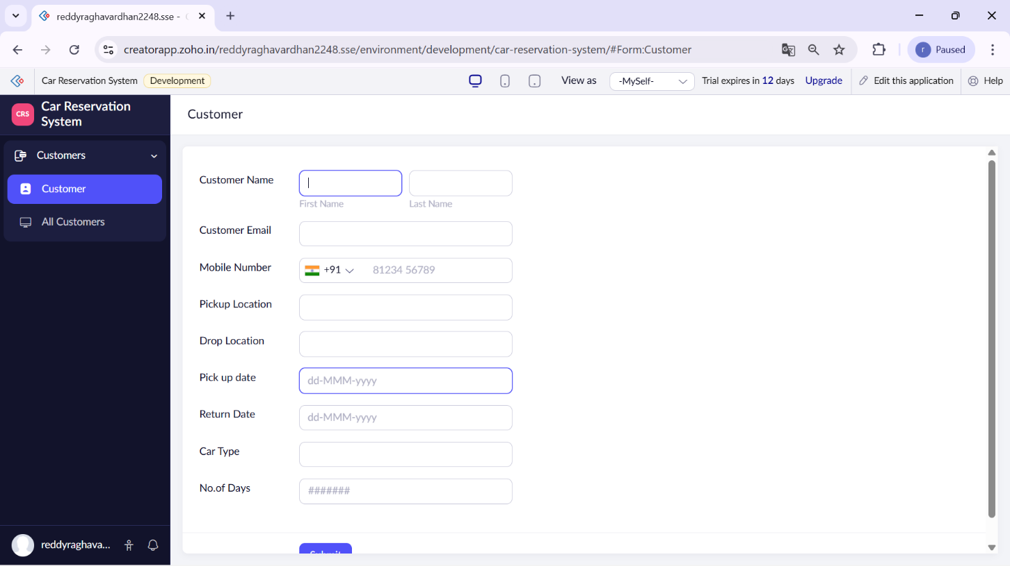

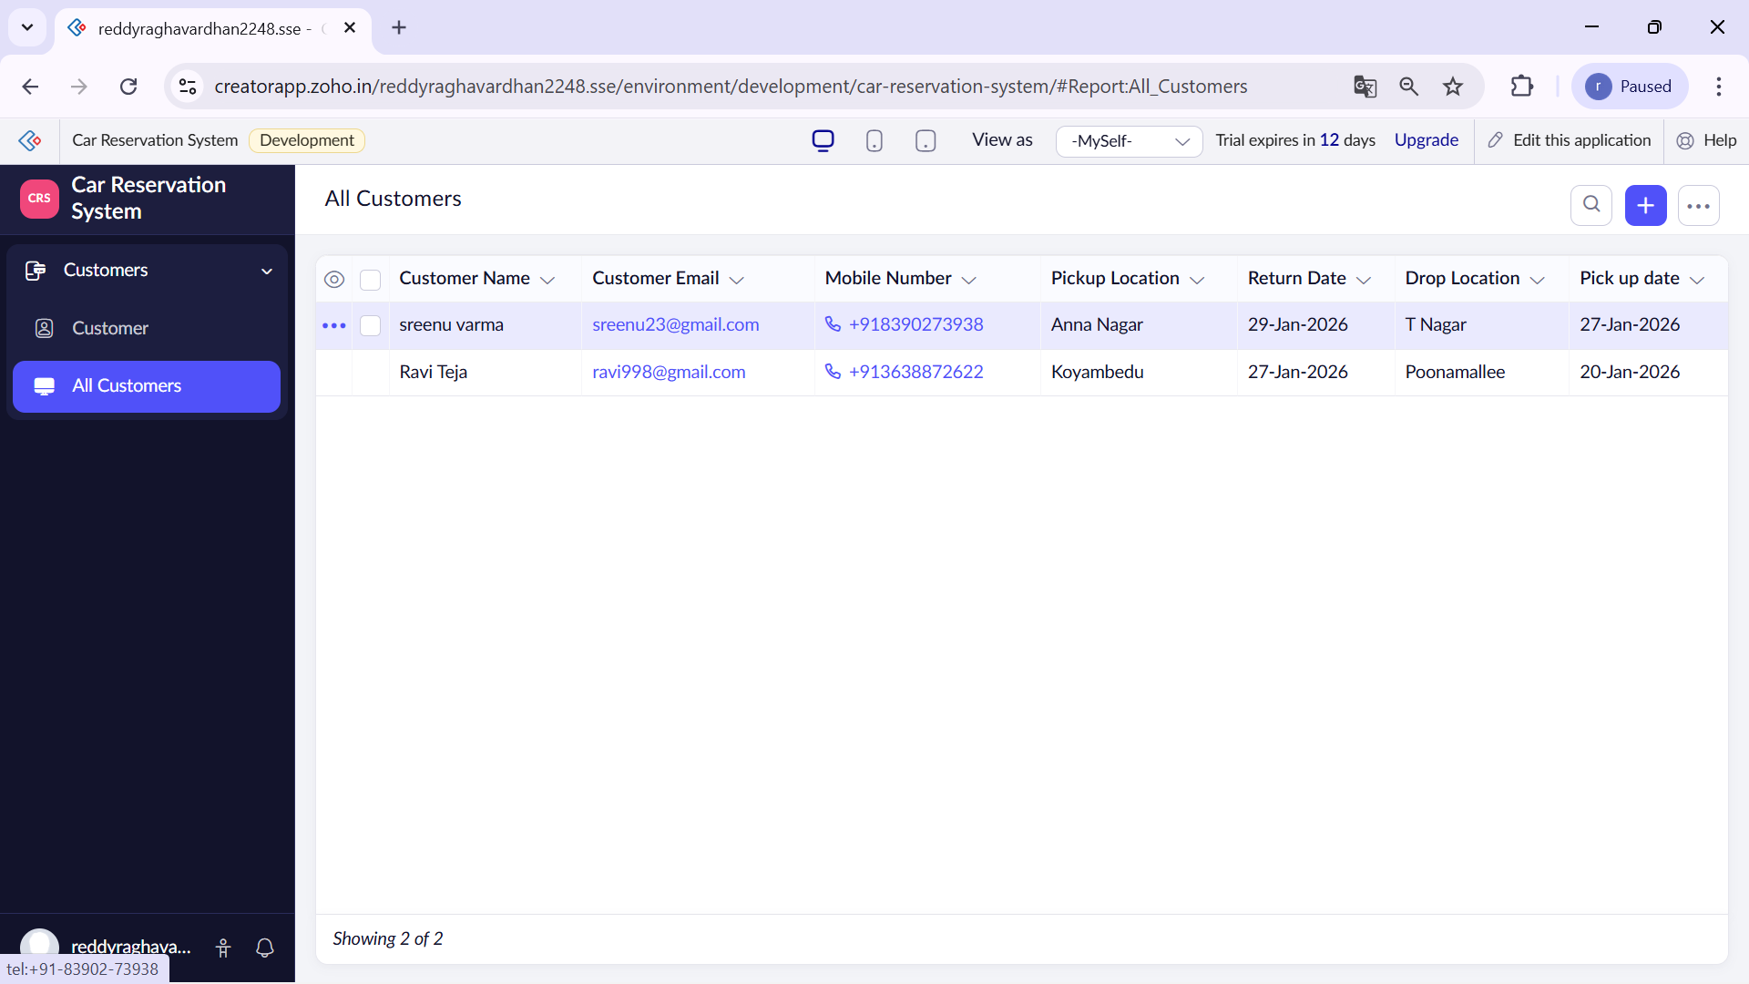

Result:
The cloud-based Property Buying and Rental SaaS application using Zoho Creator and Zoho IAM was successfully implemented with three user roles: Owner, Tenant, and Admin. Each role was provided with a separate dashboard and access permissions, ensuring secure and controlled usage of the system.

